1. Basic + bonus1
2. Basic & bonus1執行arithmetic_average_call.py

輸入function名稱、參數，呼叫function

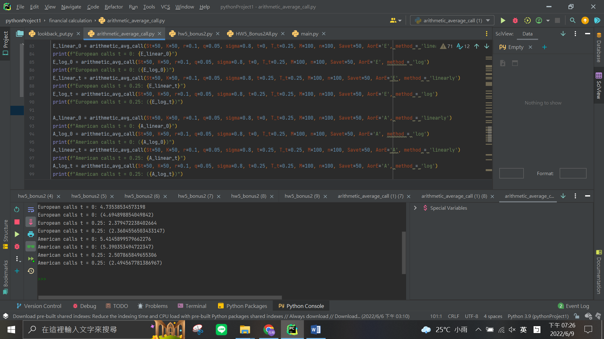

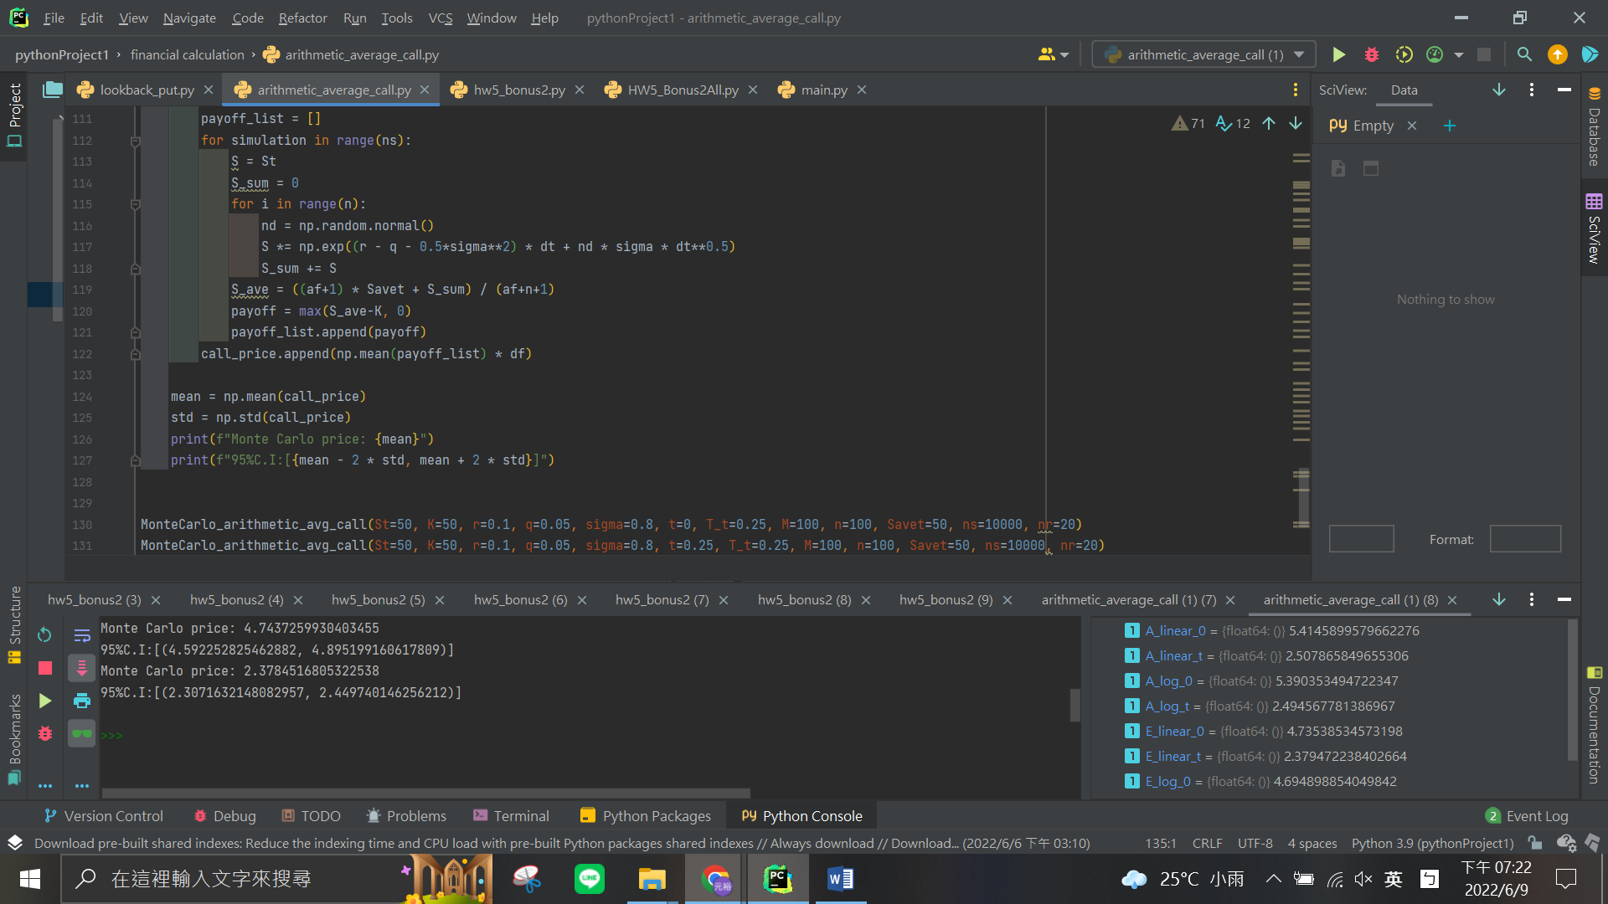

Bonus1

